Anthony Cunningham

Research Data Management

4/17/18

**Homework 5**

1)

**DATA** temp_long;

SET temperature;

ARRAY F{**24**} fahren1 - fahren24;

ARRAY C{**24**} celsius1-celsius24;

DO hour = **1** to **24**;

Fahrenheit = F{hour};

Celsius = C{hour};

FORMAT Celsius **4.1**;

IF (Fahrenheit NE **.** AND Celsius NE **.**) THEN OUTPUT;

END;

KEEP hour Fahrenheit Celsius;

**RUN**;

**PROC** **PRINT** DATA = temp_long;

**RUN**;

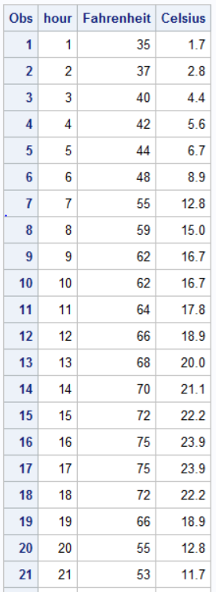

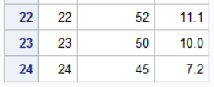

2)

LIBNAME hw5 "H:\My SAS Files";

**DATA** demographics;

SET hw5.demographics;

**RUN**;

**DATA** qol;

SET hw5.qol;

**RUN**;

**PROC** **SORT** DATA = demographics;

BY id;

**RUN**;

**PROC** **SORT** DATA = qol;

BY id;

**RUN**;

**DATA** primary_analysis;

MERGE demographics qol;

BY id;

**RUN**;

**PROC** **REPORT** DATA = primary_analysis;

COLUMN sex visit grade,survey,(N MEAN);

DEFINE sex / GROUP "Sex";

DEFINE visit / GROUP "Visit #";

DEFINE grade / ACROSS "Grade";

DEFINE survey / "Survey";

DEFINE MEAN / FORMAT = **4.1**;

**RUN**;

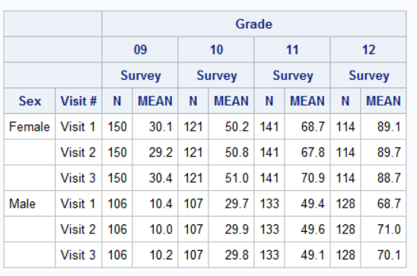

* Across the board, the average surveyed student’s quality of life was greater as grade level increased, regardless of Visit # or Sex. Also, the average surveyed Female student’s quality of life was greater than the average surveyed Male student regardless of grade level or Visit #.

**PROC** **REPORT** DATA = primary_analysis;

COLUMN sex visit grade,survey,(N MEAN) weightedAverage;

DEFINE sex / GROUP "Sex";

DEFINE visit / GROUP "Visit #";

DEFINE grade / ACROSS "Grade";

DEFINE survey / "Survey";

DEFINE MEAN / FORMAT = **4.1**;

DEFINE weigtedAverage / COMPUTED "Weighted Average";

COMPUTE weightedAverage;

weightedAverage = (_c3_*_c4_ + _c5_*_c6_ + _c7_*_c8_ + _c9_*_c10_) / (_c3_ + _c5_ + _c7_ + _c9_);

ENDCOMP;

**RUN**;

